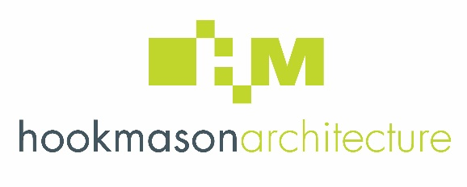

Subject Access Request Form

To request details of any personal data Hook Mason Ltd may hold about you, please complete this form and provide it together with a colour photocopy of a photographic identity document (e.g., passport) to: The Data Representative, Hook Mason Ltd, Studio 2, Thorn Office Centre, Rotherwas, Hereford, HR2 6JT.
For security reasons you are advised to use a recorded delivery method of posting

Hook Mason Ltd will respond to your request within 30 days of your correctly completed application form being received. No fees are payable. If you have any queries, questions or comments please contact the Data Representative by tel. 01432 352299 or info@hookmason.co.uk

Full Name:
Home Address:
Project Address:
Email Address:
Telephone Number:

I wish to make a subject access request in relation to my personal data which may be held by Hook Mason Ltd. I understand that there will be no charge to provide this data to me. I have attached a colour copy of a photographic identity document to confirm my identity. I am aware that I may commit an offence if I seek to obtain data for which I am not the data subject.
I have read the notes overleaf about my subject access rights.

Signed: Print Name: Date:

Subject Access Rights
The right to make a subject access request is most often used by individuals who want to see a copy of the information the company or organisation holds about them. An individual who makes a written request is entitled to be:
• Told whether any personal data is being processed;
• Given a description of the personal data, the reasons it is being processed, and whether it will or has been given to any other company, organisation or people; and
• Given a copy of the information comprising the data and given details of the source of the data (where this is available).
In most cases, your subject access request must be responded to promptly and in any event within 30 calendar days of your properly completed request being received. This is not a full explanation of the law.

